38.54: a) 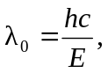 and the wavelengths are: cesium: 590 nm, copper: 264 nm, potassium: 539 nm, zinc: 288 nm. b) The wavelenghts of copper and zinc are in the ultraviolet, and visible light is not energetic enough to overcome the threshold energy of these metals.

